# Carbon Installation and Usage Guide

In this document, you will find instructions on how to install and use Carbon.

## Installation

### Supported Operating Systems

* Windows - Windows 10, Windows 8, Windows 7, Windows Server 2016, Windows Server 2012 (64-bit), Windows Server 2012 R2 (64-bit)
* Mac – macOS 10.10 or higher
* Linux - Ubuntu 16.04 and 16.10, Red Hat Enterprise Linux (RHEL) 7.3, CentOS 7, OpenSUSE v13.2

## Install Carbon

#### Windows

* Download the **2017-may-30-carbon-private-preview-carbon-win32.zip** file for Windows.
* Once it is downloaded, unzip the file and double click Carbon.exe to launch the application.

#### macOS

* Download the **2017-may-30-carbon-private-preview-carbon-macOS.zip** file for macOS
* Double-click on the downloaded archive to expand the contents.
* Drag **carbon.app** to the Applications folder, making it available in the Launchpad.
* Click on Carbon in the Applications folder to launch the application.

#### Linux

Ubuntu

* Download the 2017-may-30-carbon-private-preview-linux-x86-deb.tar.gz file and save it to your HOME folder.
* Execute the following command in a terminal window:
  + $ cd ~
  + $ tar xvf ./ 2017-may-30-carbon-private-preview-linux-x86-deb.tar.gz
  + $ sudo dpkg -i carbon-private-preview-linux-x86.deb
* Run the following commands to launch Carbon:
  + $ ~/carbon-linux-x64/carbon

Red Hat Enterprise on Linux and CentOS

* Download the 2017-may-30-carbon-private-preview-linux-x86-rpm.tar.gz file and save it to your HOME folder.
* Execute the following command in a terminal window:
  + $ cd ~
  + $ tar xvf ./ 2017-may-30-carbon-private-preview-linux-x86-rpm.tar.gz
  + $ sudo yum localinstall carbon-private-preview-linux-x86.rpm
* Run the following commands to launch Carbon:
  + $ ~/carbon-linux-x64/carbon

openSUSE, Fedora

* Download 2017-may-30-carbon-private-preview-linux-x86-rpm.tar.gz file and save it to your HOME folder.
* Execute the following command in a terminal window:
  + $ cd ~
  + $ tar xvf ./ 2017-may-30-carbon-private-preview-linux-x86-rpm.tar.gz
  + $ sudo zypper install $ ~/carbon-linux-x64/carbon
* Run the following commands to launch Carbon:
  + $ ~/carbon-linux-x64/carbon

## Usage

We recommend you install SQL Server for the best experience. Please visit the following page for installation instructions:

<https://www.microsoft.com/en-us/sql-server/sql-server-2017#resources>

### Add Server Groups and Connections to Carbon

After you launch Carbon, you will see the “New Connection” flyout where you can enter the information below to connect to your server:

1. Type in your

|  |  |
| --- | --- |
| Connection Type | Restricted to **Microsoft SQL Server** in private preview |
| Server Name | Enter the name of the target SQL Server machine or its IP address |
| Authentication Type | Select “Windows Authentication” if you are running Carbon on Windows and connecting to SQL Server on Windows  Select “SQL Server Authentication” otherwise |
| User Name | Enter the name of a user with access to a database on this server. For example the default **SA** account created during SQL Server setup. |
| Password | Enter the password for the specified user. |
| Database Name |  |
| Add to Server group |  |

Connection type: Server Name, User Name, and Password.

1. Click Connect.

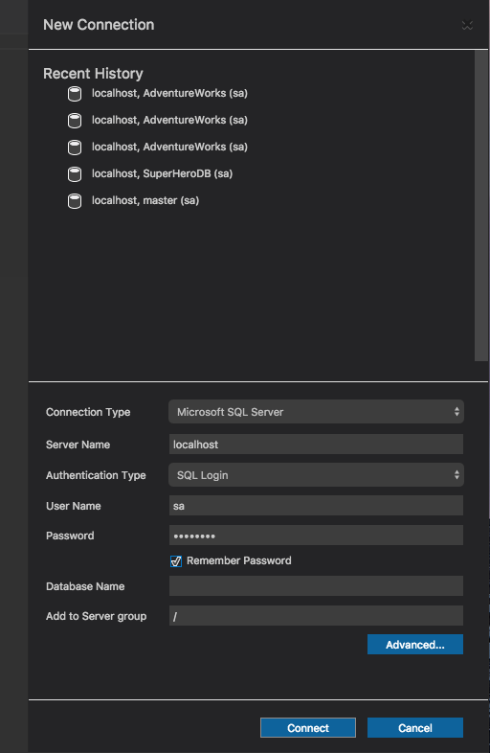

1. View your newly created connection profile in “Server Groups” section in the connection viewlet on the left side of the app in the Server Groups dropdown.

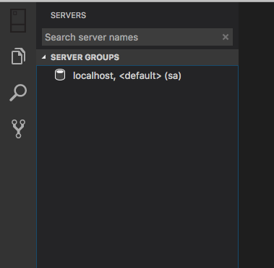

1. Click on the “+” to add a server group
2. Enter in your Connection Group Name and Group Description in the “Add Server Group” dialog

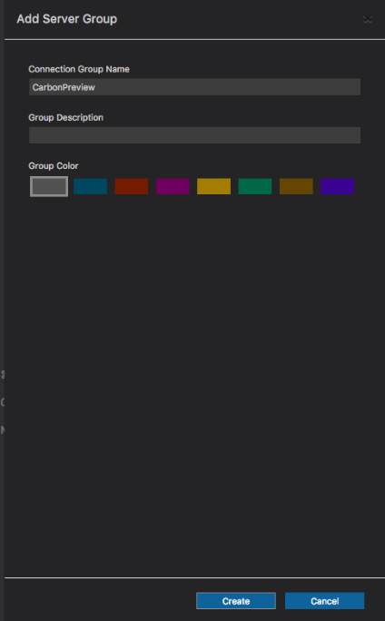

1. Take your connection and drag and drop it on top of the new group to add it to the group.

### C:\Users\taraj\AppData\Local\Microsoft\Windows\INetCache\Content.Word\groupcreation3.png

### C:\Users\taraj\AppData\Local\Microsoft\Windows\INetCache\Content.Word\groupcreation4.png

### Connect to a Database

1. Select a connection and double click it
2. Expand the databases folder to browse the SQL database and the object contents

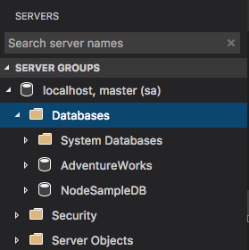

### C:\Users\taraj\AppData\Local\Microsoft\Windows\INetCache\Content.Word\manage1.png

### Create a New Database

1. Click on “Create Database” on the management home page,
2. Type in a Database name and click “OK” to create the database

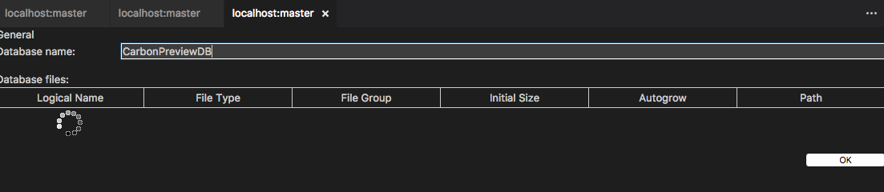

1. Go to the Object explorer, after you finish with the dialog, and select the database and click “Refresh” to ensure your change has been made.

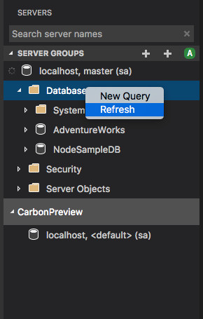

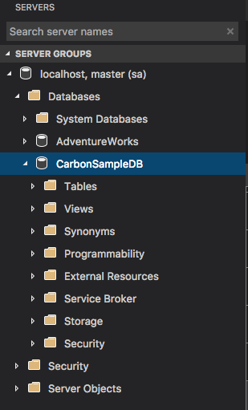

### Edit Data Experience

1. Select a database – control + click and select a new query

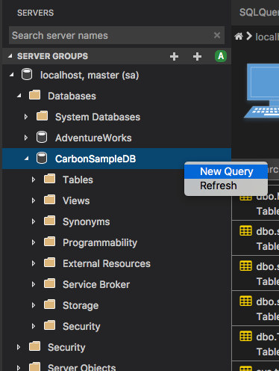

1. Use the editor to create a table by selecting the “sqlcreateTable” code snippet:

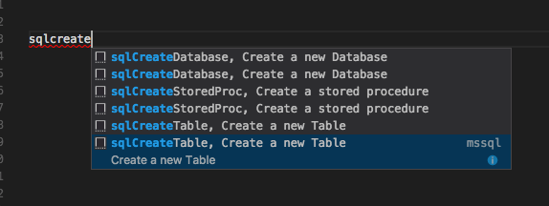

1. Go to back to the Object Explorer and select the table you just created and control + click and select “Edit Data”

<NEED A SCREENSHOT HERE>

1. Change a field to update directly in the table and hit “Return”
2. Select a table and control + click to “Select Top 100”

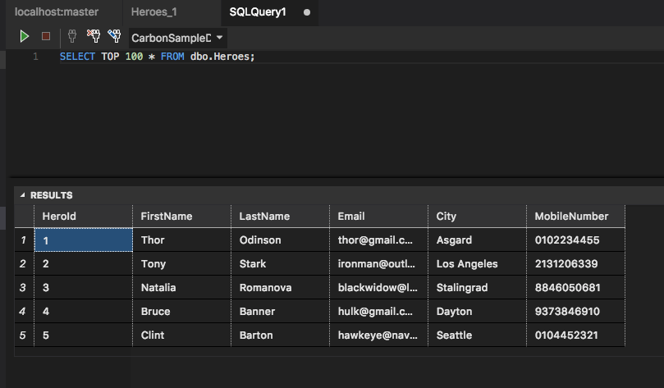

1. Save your results as JSON by selecting the “Save as JSON” button and naming your file “heroes.json” and click “Enter”

